Module 4: Load balance non-HTTP(S) traffic in Azure

# Chapter 2: Explore load balancing

* Load balancing (LB) is the even distribution of workloads (incoming network traffic), across a group of back-end computing resources or servers.

## Load Balancing options for Azure

* *Azure Load Balancer* (LB) - high-performance, ultra-low-latency Layer 4 load-balancing service (inbound and outbound) for all UDP and TCP protocols.
  + It is Zone-redundant
* *Traffic Manager* - DNS-based traffic load balancer that distributes traffic optimally to services across global Azure regions
  + It load-balances only at the domain level
* *Azure Application Gateway*
* *Azure Front Door* - application delivery network

## Categorizing load balancing services

### Global versus regional

* **Global** load-balancing distributes traffic across regional back-ends, clouds, or hybrid on-premises
* **Regional** load-balancing distributes traffic within VNETS across VMs or zonal/zone-redundant service endpoints within a region

### HTTP(S) versus non-HTTP(S)

* **HTTP(S)** load-balancing services are Layer 7 LBs --> only accept HTTP(S) traffic.
* **non-HTTP(S)** load-balancing services --> non-HTTP(S) traffic and are recommended for non-web workloads.
* **Diagram**:
  + 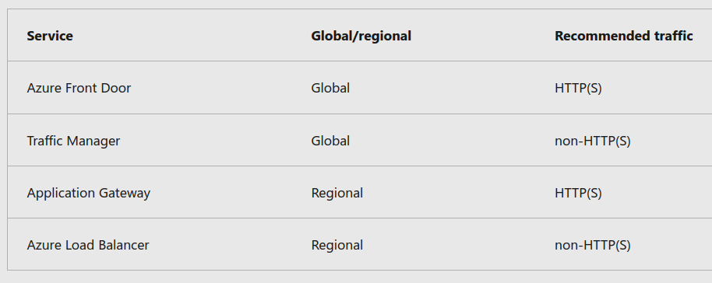
* Choosing Load Balancing Options:
  + 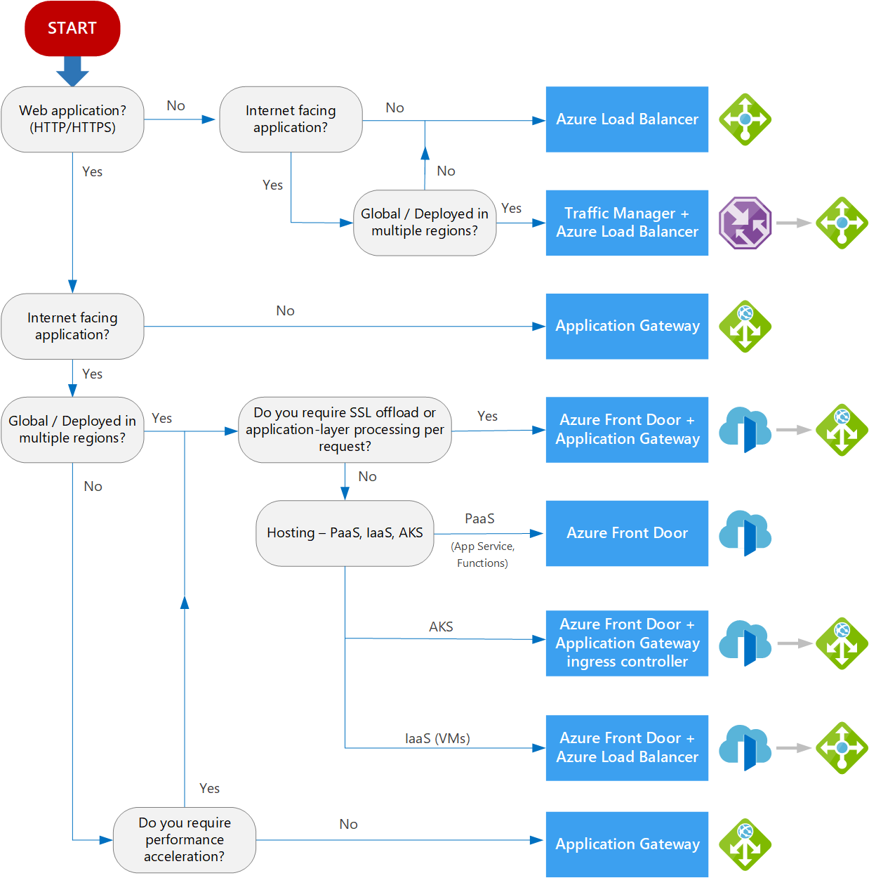

# Chapter 3: Design and implement Azure load balancer using the Azure portal

## Choosing a load balancer type

* **Public load balancer** 
  + Provide outbound for VMs inside VNET.
    - It translating their private IP addresses to public IP addresses.
    - External LBs distribute client traffic from the internet across your VMs
* **Internal load balancer** 
  + Used where private IPs are needed at the frontend only.
  + Used to load balance traffic from internal Azure resources to other Azure resources inside a VNET.
* 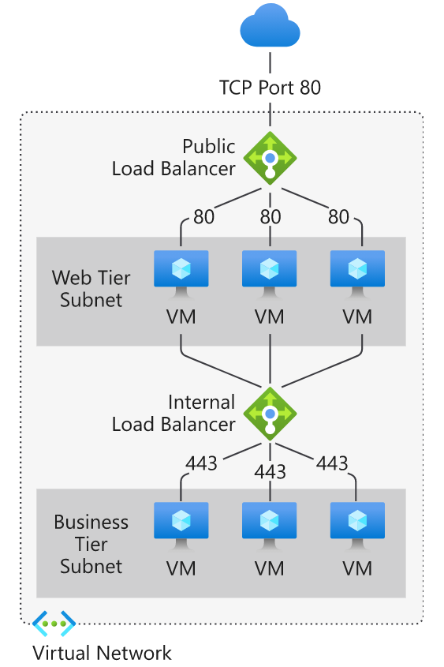

## Azure load balancer and availability zones

### Load Balancer Zone Types

#### 1) Zone redundant - Resources replicated/distributed across zones

* Standard LBs can be zone-redundant (single IP address)
  + The front-end IP is used to reach all back-end pool members (will survive as long as 1 Avail. zone is healthy)
* 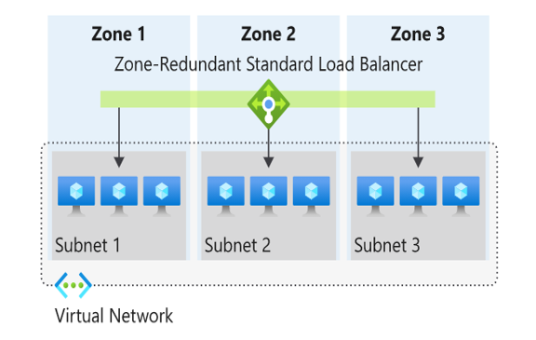

#### 2) Zonal - Resources can be pinned to a specific zone

* In/Outbound flow is served by a single zone in a region.
  + Used to test per zone load-balanced endpoints to individually monitor each zone.
* 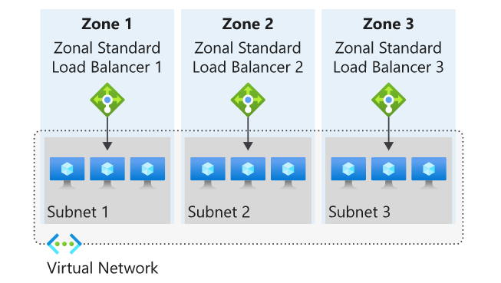
* **Public LB front-end**
  + Add a zones parameter to the public IP which is referenced by front-end IP configuration used by the respective rule.
* **Internal LB front-end**
  + A zonal front-end guarantees an IP address in a subnet to a specific zone.

## Selecting an Azure load balancer SKU

* Standard vs. Basic LB SKUs
  + 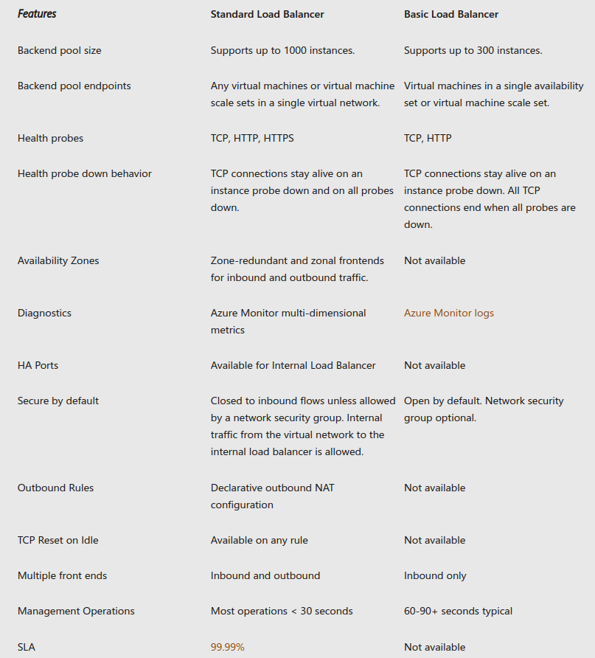
  + Load Balancing rules for the LB distributes incoming traffic that is sent to a selected IP address and port combination across a group of back-end pool VM instances.
    - Only back-end instances that the health probe considers healthy receive new traffic.

# Chapter 5: Explore Azure Traffic Manager

* Azure Traffic Manager (TM) is a DNS-based traffic load balancer.
  + Distribute traffic to public facing applications across the global Azure regions via endpoints
  + Directs client req. to appropriate service endpoint and monitors its health
  + 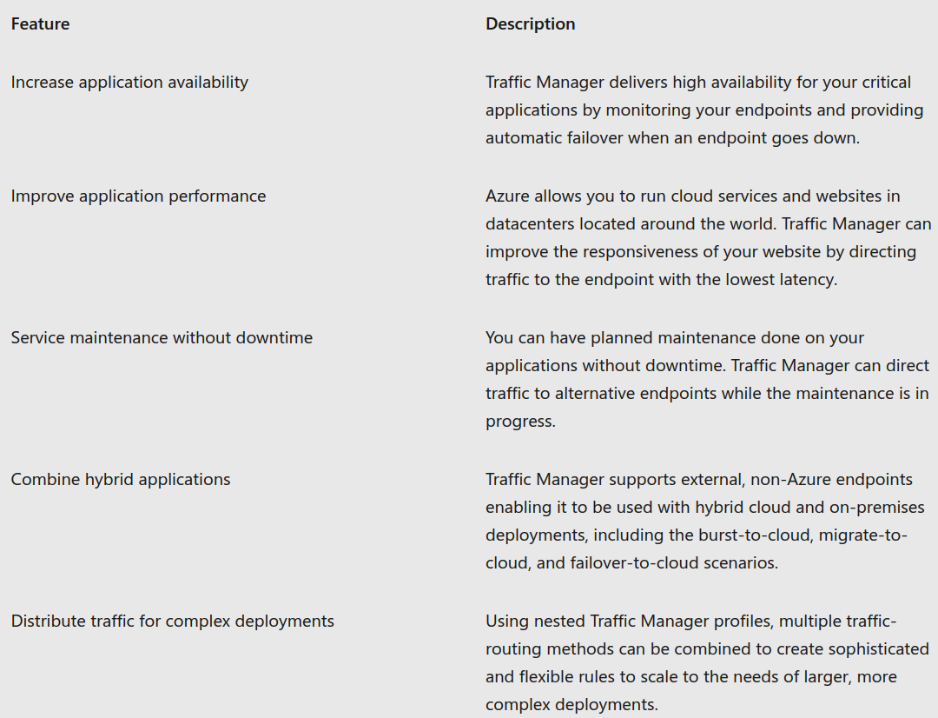

## How Traffic Manager works

* Enables control of distribution of traffic across app endpoints (any Internet-facing service hosted inside or outside of Azure)
  + 2 key benefits:
    - **Distribution of traffic** according to one of several traffic-routing methods
    - Continuous **monitoring** of endpoint health and automatic fail-over

## Traffic Manager example deployment

* An app is hosted in 3 regions of Azure.
  + To improve availability/maximize global performance, TM is used to distribute client traffic to the closest available endpoint.
* **Steps**:
  + Deploy three instances of their service which have 3 DNS names
    - * **Ex**. contoso-us.cloudapp.net, contoso-eu.cloudapp.net, and contoso-asia.cloudapp.net.
  + Create TM profile, named contoso.trafficmanager.net,
    - Configure it to use the 'Performance' traffic-routing method across the three endpoints.
  + Configure their vanity domain name to point to contoso.trafficmanager.net, using a DNS CNAME record.

## Client Usage View of TM

* 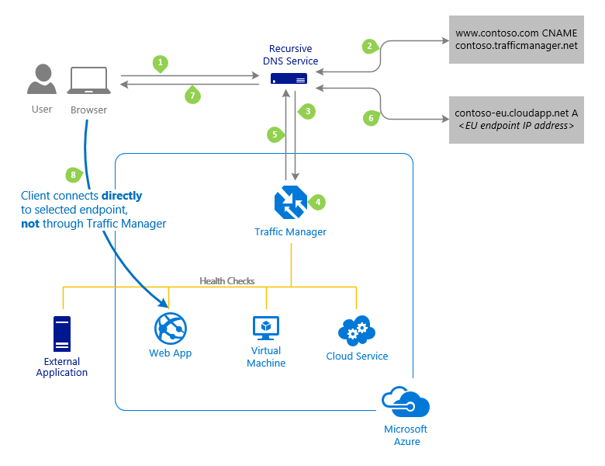
  + Refer: https://learn.microsoft.com/en-us/training/modules/load-balancing-non-https-traffic-azure/5-explore-azure-traffic-manager

## 6 Traffic routing methods

* 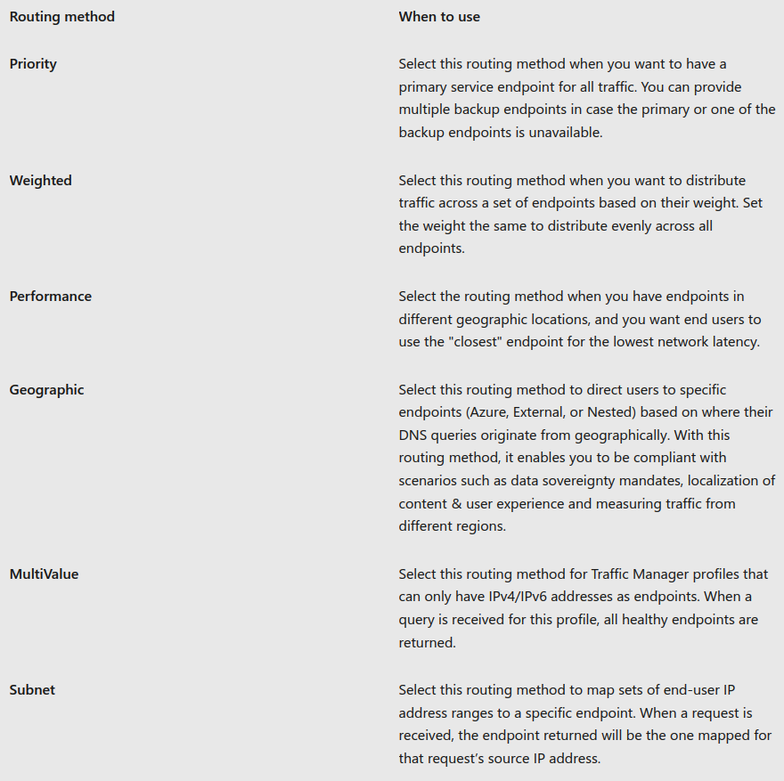
* **Priority** Method:
  + 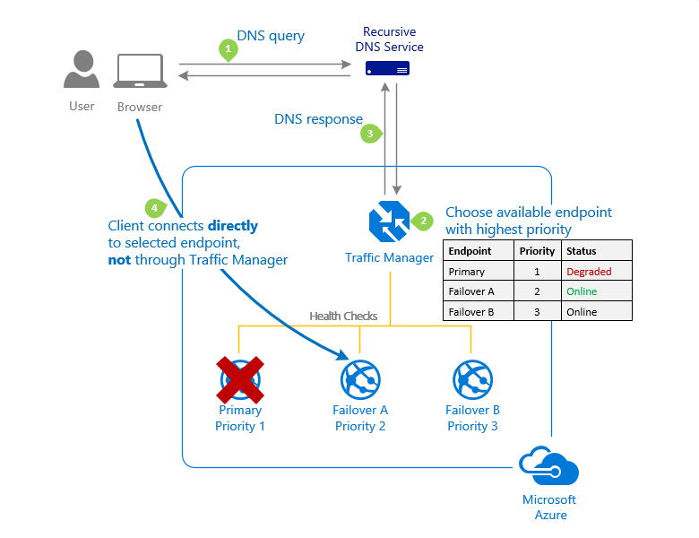
* **Weighted** Method:
  + 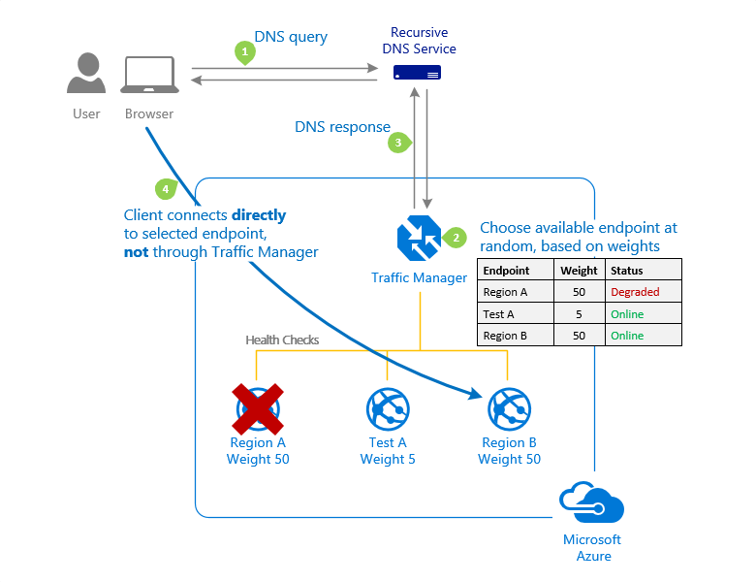
* **Performance** Method:
  + 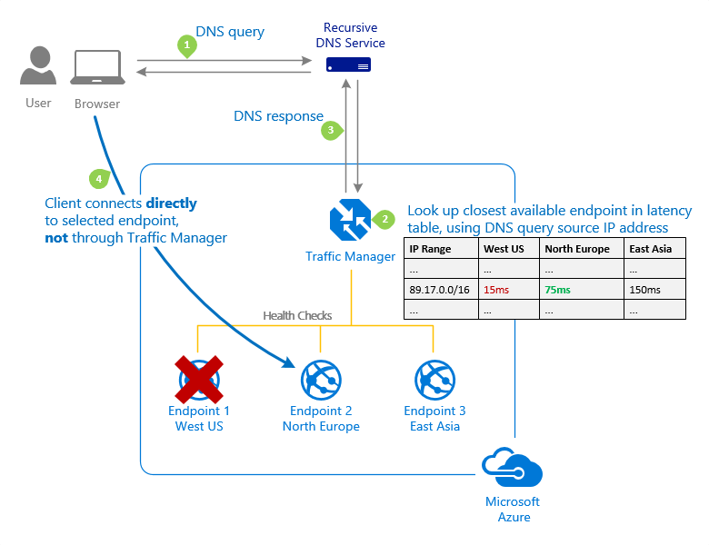
* **Geographic** Method:
  + 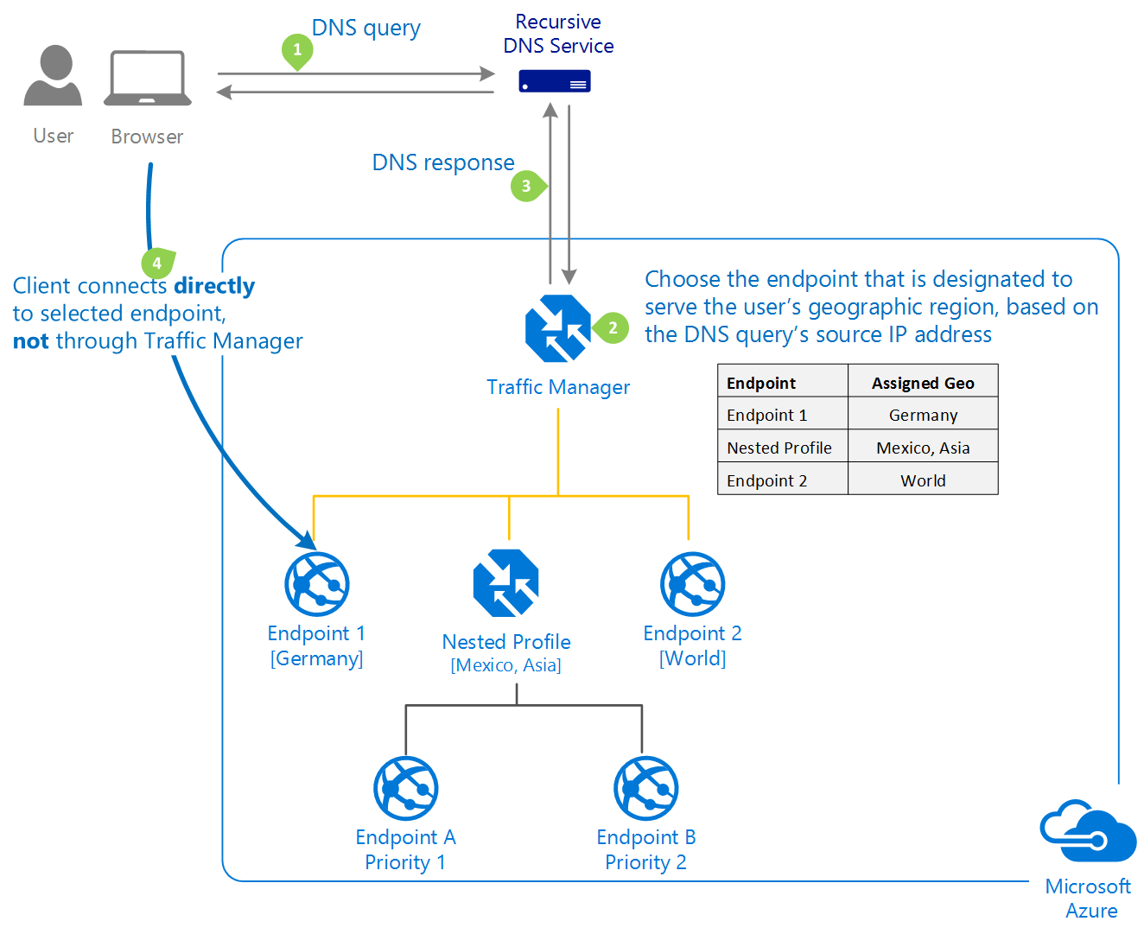

## Traffic Manager Profiles

* Per profile, *only configure 1 method* of traffic routing at a time (All profiles have health monitoring and automatic fail-over of endpoints).
  + But to combine traffic routing methods use **NESTED** **TM profiles** to use multiple traffic-routing methods.
    - Nested profiles override default TM behaviour to support larger/more complex traffic-routing configurations for app deployments.
* **Example**:
  + 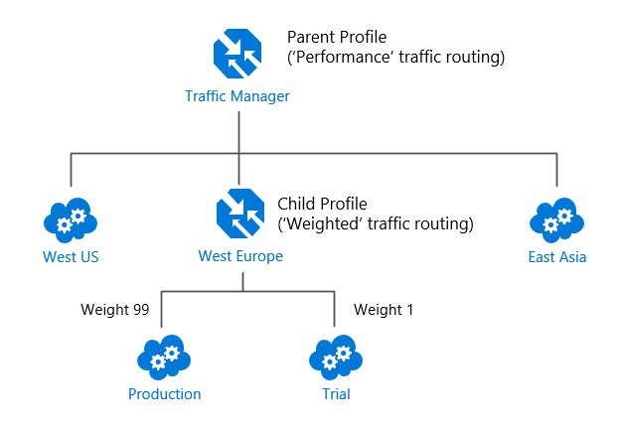
  + In above configuration, traffic directed via the **parent profile** (Performance routing) distributes traffic across regions normally.
    - BUT for West Europe, the **nested child** profile (Weighted routing) distributes traffic to the production & test endpoints according to the weights

## Traffic Manager endpoints

* You configure each app deployment as an endpoint in TM.
* TM supports 3 endpoints:
  + **Azure endpoints –** used to LB traffic to a cloud service, web app, or public IP address in the same subscription *within Azure*.
  + **External endpoints –** used to LB traffic for IPv4/IPv6 addresses, FQDNs, or for services hosted *outside Azure*.
    - Either on-premises or with different cloud.
  + **Nested endpoints** – used to combine TM profiles for more flexible traffic-routing schemes to *larger, complex deployments*.
    - Child profile is added as an endpoint to a parent profile.
    - Child/parent profiles can contain other endpoints (ex. other nested profiles).